User Manual Specification
Release Version -1.1
For
Meghna Solar Ltd.
Concern Topic: Inventory Management

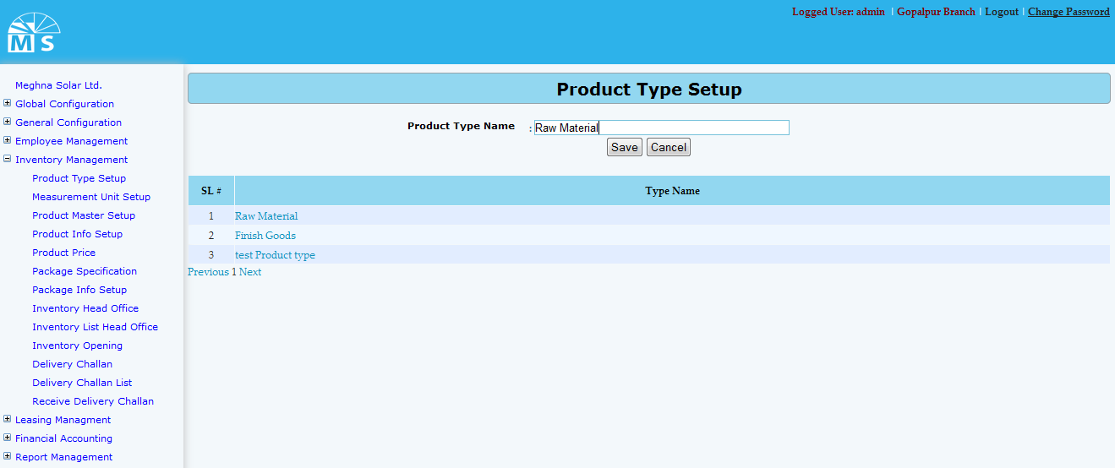

Product type Setup

Here user needs to enter Product type name in the text box and click Save Button to save Product type name information. Recently saved Product type information will be visible in the below grid view. For updating any information user need to click on Type name in the grid view. After modifying the name, user need to Press Update button. After that, modified Product type information will be available in the grid view.
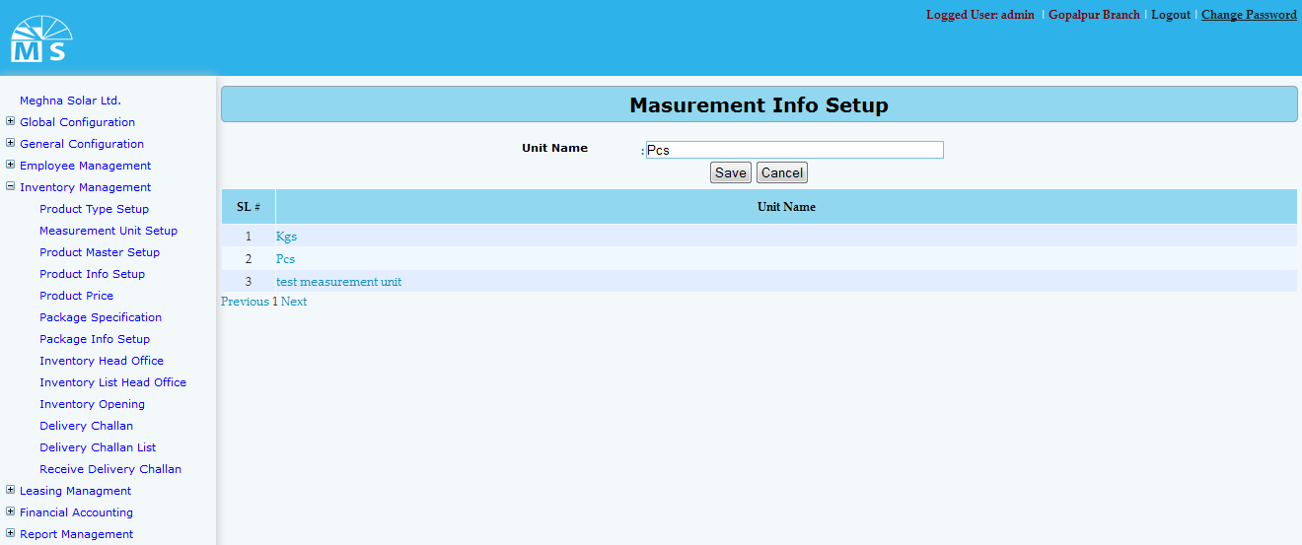

Measurement unit Setup

Here user needs to enter Measurement unit name in the text box and click Save Button to save Measurement unit name information. Recently saved Measurement unit information will be visible in the below grid view. For updating any information user need to click on unit name in the grid view. After modifying the name, user need to Press Update button. Then, modified Measurement unit information will be available in the grid view.
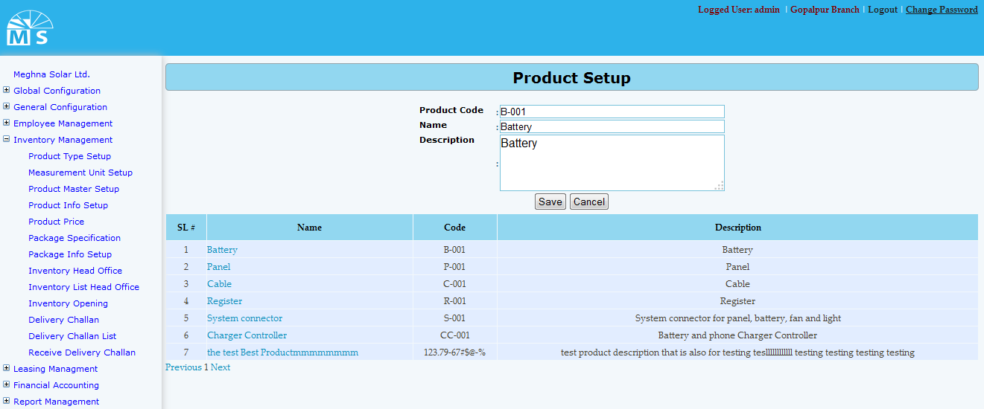

Product master setup

Here user needs to enter Product Code, Product name and Product description in the text field. Then user need to click Save Button to save Product master setup information. Recently saved information will be visible in the grid view. For updating any informartion user need to click on Product name in the grid , modify info in text box and click update button to see modified info in the grid view.
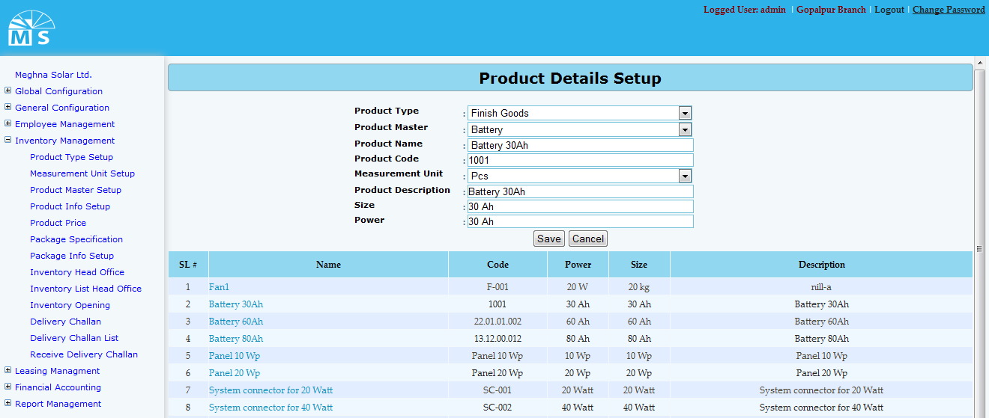

Product Details setup

Here user needs to select Product Type and Product Master form the top two drop down list. Then user need to enter Product Code, Product name . After that selecting measurement unit from dropdown list user also neeed to enter product description, Size and Power in the text field. Then user need to click Save Button to save Product details information. Recently saved information will be visible in the grid view. For updating any informartion user need to click on Product name in the grid , modify info in text box and click update button to see modified info in the grid view.

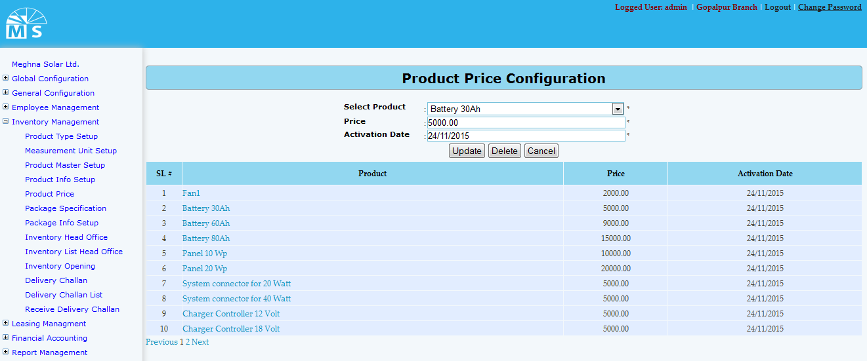

Product Price Configuration setup

Here user needs to select Product form the top drop down list. Then enter Product price and Activation date. Then for new product user need to click Save Button and for existing price user need to click update button to save Price information. Recently saved/Updated information will be visible in the grid view. User also can delelte
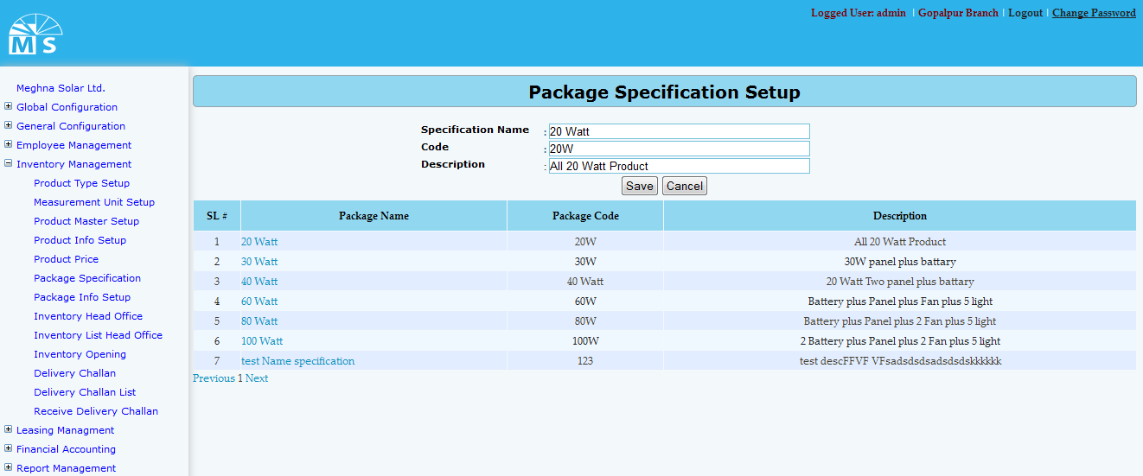

Package Specification setup

Here user needs to enter Specification name, code and description in the text box. Then user need to click Save Button to save Package Specification information. Recently saved information will be visible in the grid view. For updating any informartion user need to click on Package name in the grid , modify info in text box and click update button to see modified info in the grid view.
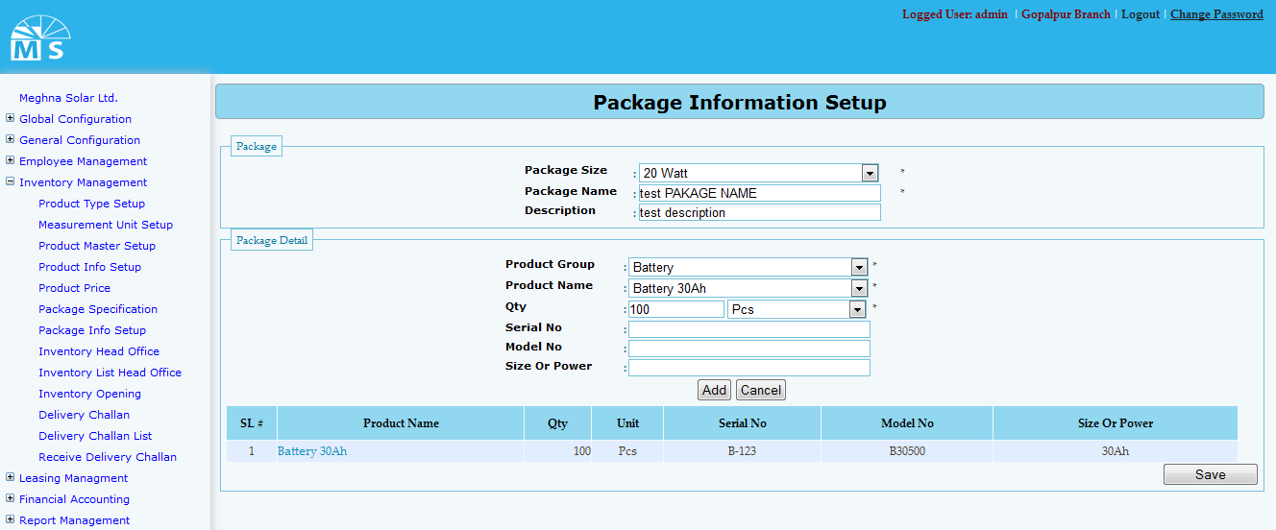

Package Information setup

Here in package section user needs to select package size from the drop down list and enter Package name and Description. Then in Package Detail user need to selelct product group, product name,Quantity,Measurement Unit from drop down list. Then he need to enter serial no,model no and size or power value in texbox. If user click Add button then the pakage detail will be visible in the gridview. Like this user can add more than one details. At last user need to click Save button to save the Package information.
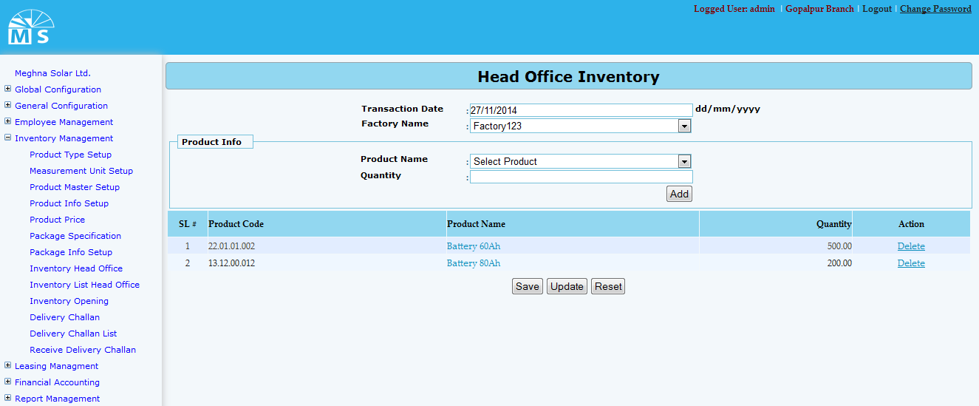

Head Office Inventory

Here in Head Office Inventory user need to enter transaction date and select factory name from drop down list. Then in Product Info section User need to select product name from drop down list and enter quantity value to add product in the gridview. Besides adding product User can also delete product from gridview. Then at last User need to press save button for new entry and update button for modifying existing information.At last user need to save the whole Inventory information by clicking Save button.

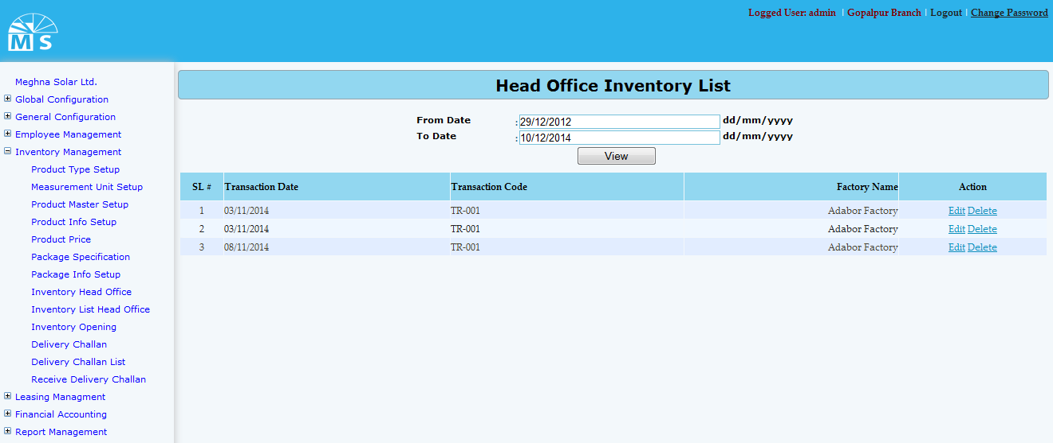

Head Office Inventory List

Here in Head Office Inventory List user can search/view inventory list by inserting from date and to date. After clicking view button inventory list between the dates will be shown in the grid. From there user can edit or delete inventory details.
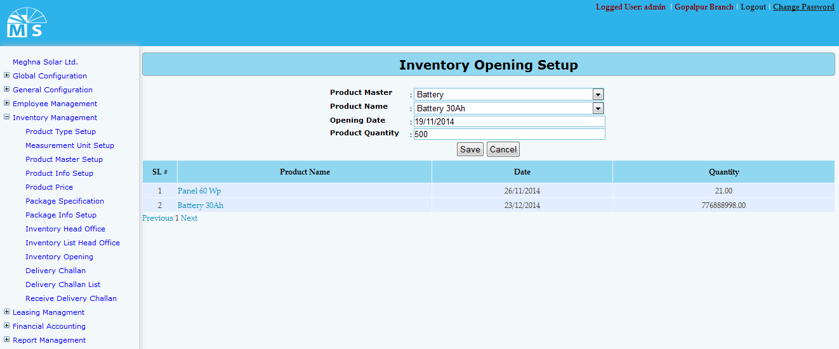

Inventory Opening Setup

Here in Inventory Opening Setup user need to enter Product master and product name from drop down list. Then need to enter opening date and product quantiy to save Inventory Opening Setup information. After clicking save button information will be visible in the gridview. For updating user need to click on product name to update any information.

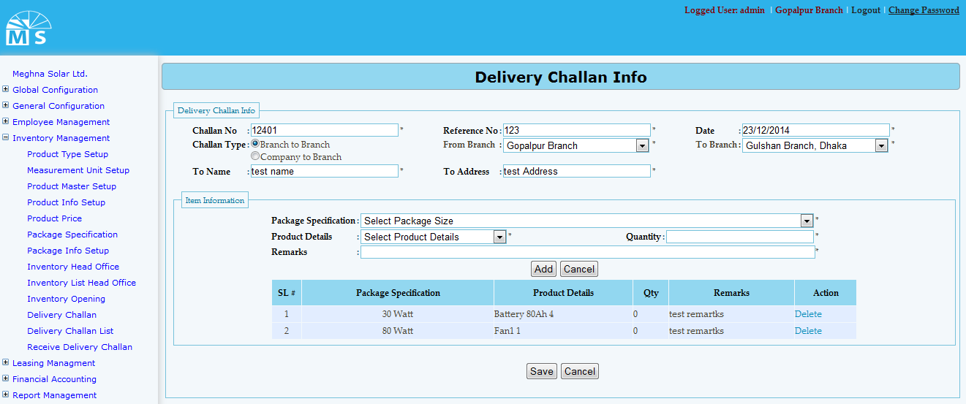

Delivery Challan Info

Here in Delivery Challan Info there is two section. At first in delivery challan info section user need to enter challan no, referrence no,challan type, date, branch, to name and challan address. Then in Item info section user need to sellect package specification and package detail from drop down list. Then user need to enter quantity and remarks to add item info in grid. User can add more than one item info. At last user need to click save button to save delivery challan info.

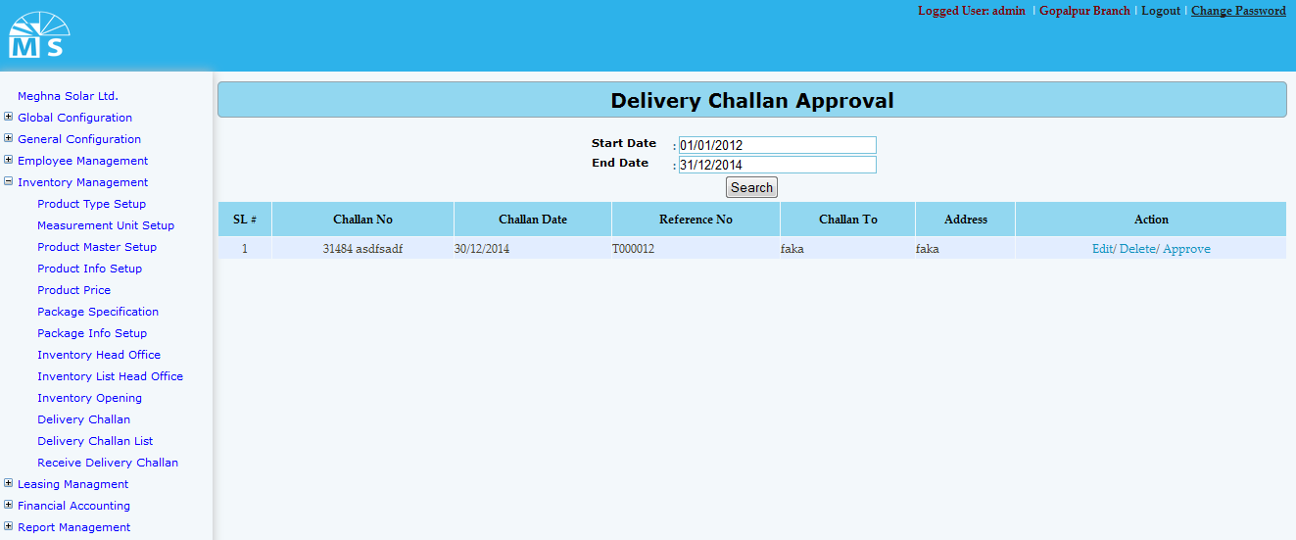

Delivery Challan Approval

Here in Delivery Challan Approval user can search delivery challn info date wise. After providing Start and end date user need to click search button. Then the delivery challn info become visible in the grid view.From there user can Edit, dellete or appve the delivery challan info

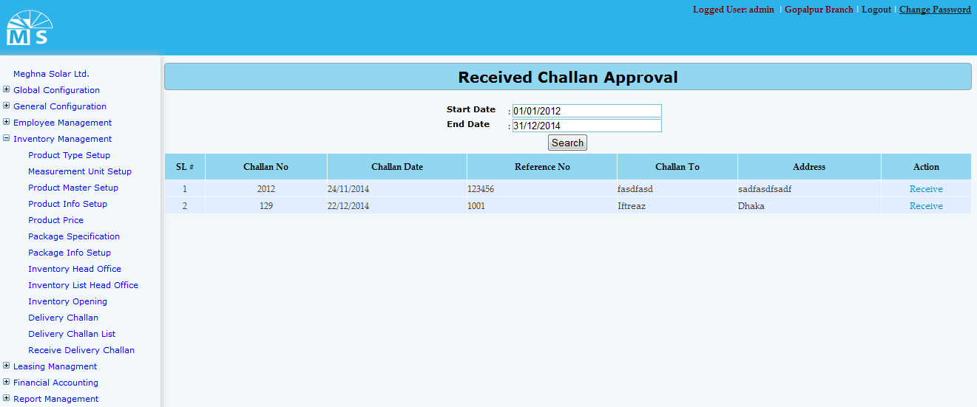

Received Challan Approval

Here in Received Challan Approval user can search receive challn date wise and also can approve them as well. For that user need to enter start and end date and click search button. Then received challn between the date range will be visible in the grid. Fron there user can receive Challan.

